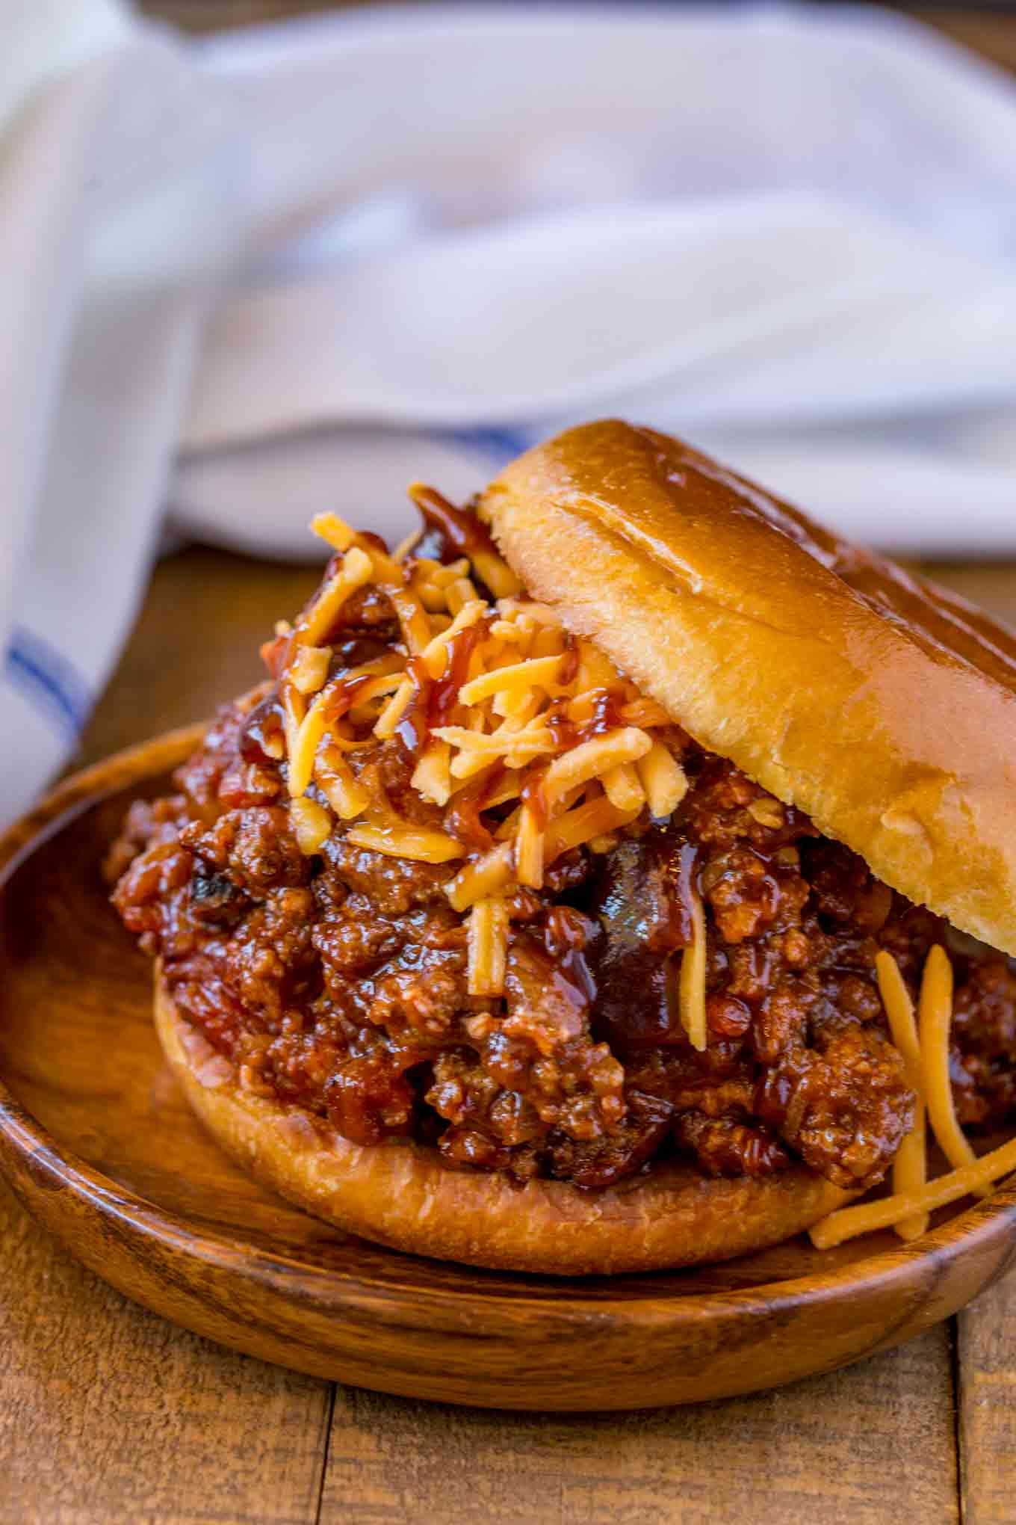
BBQ Beef Sloppy Joes
Prep time 10 min Cook time 20 minutes
8 Sandwiches

Ingredients
1½ lbs lean ground beef 85/15
1 yellow onion diced
14.5 oz diced tomatoes drained
1 cup beef broth
½ cup ketchup
½ cup barbecue sauce
1 tbsp Worcestershire sauce
1 cup cheddar cheese shredded

Directions
- In a large skillet add the beef and onions, cooking well, breaking it apart but leaving some chunks for 5 to 6 minutes.
- Add in the canned diced tomatoes, beef broth, ketchup, barbecue sauce and Worcestershire sauce, cooking until the sauce starts to evaporate and the mixture becomes "sloppy" (about 5 to 6 minutes).
- Spoon the mixture onto the bun and top with shredded cheddar cheese.

